DevOps Projects 01

1. Create your own pipeline in Jenkins as a Jenkinsfile
2. Use SONAR to validate static code analysis, source code quality and it should be integrated with Jenkins pipeline.
3. If source is above 50% allow to next step or reject the build.
4. Do the build using Maven.
5. Using Ansible deploy to TOMCAT application server.

Step 01: Java, Maven, Jenkins, SonatQube-runner Installation & Set JAVA_HOME & MAVEN_HOME as environment variables on Jenkins machine

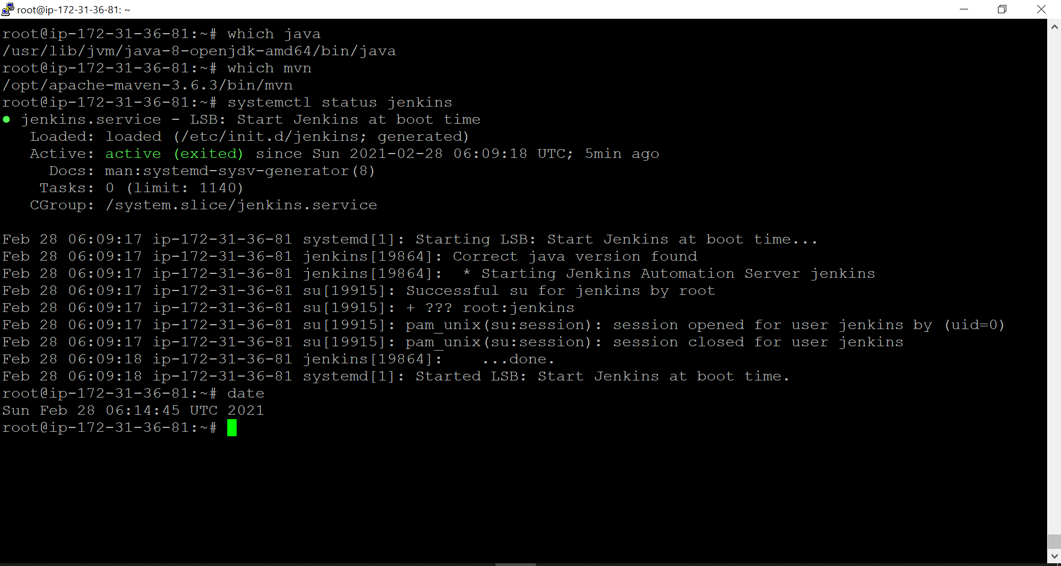

Step 02: Jenkins Configuration

Jenkins URL : <http://172.31.36.81:8080/>

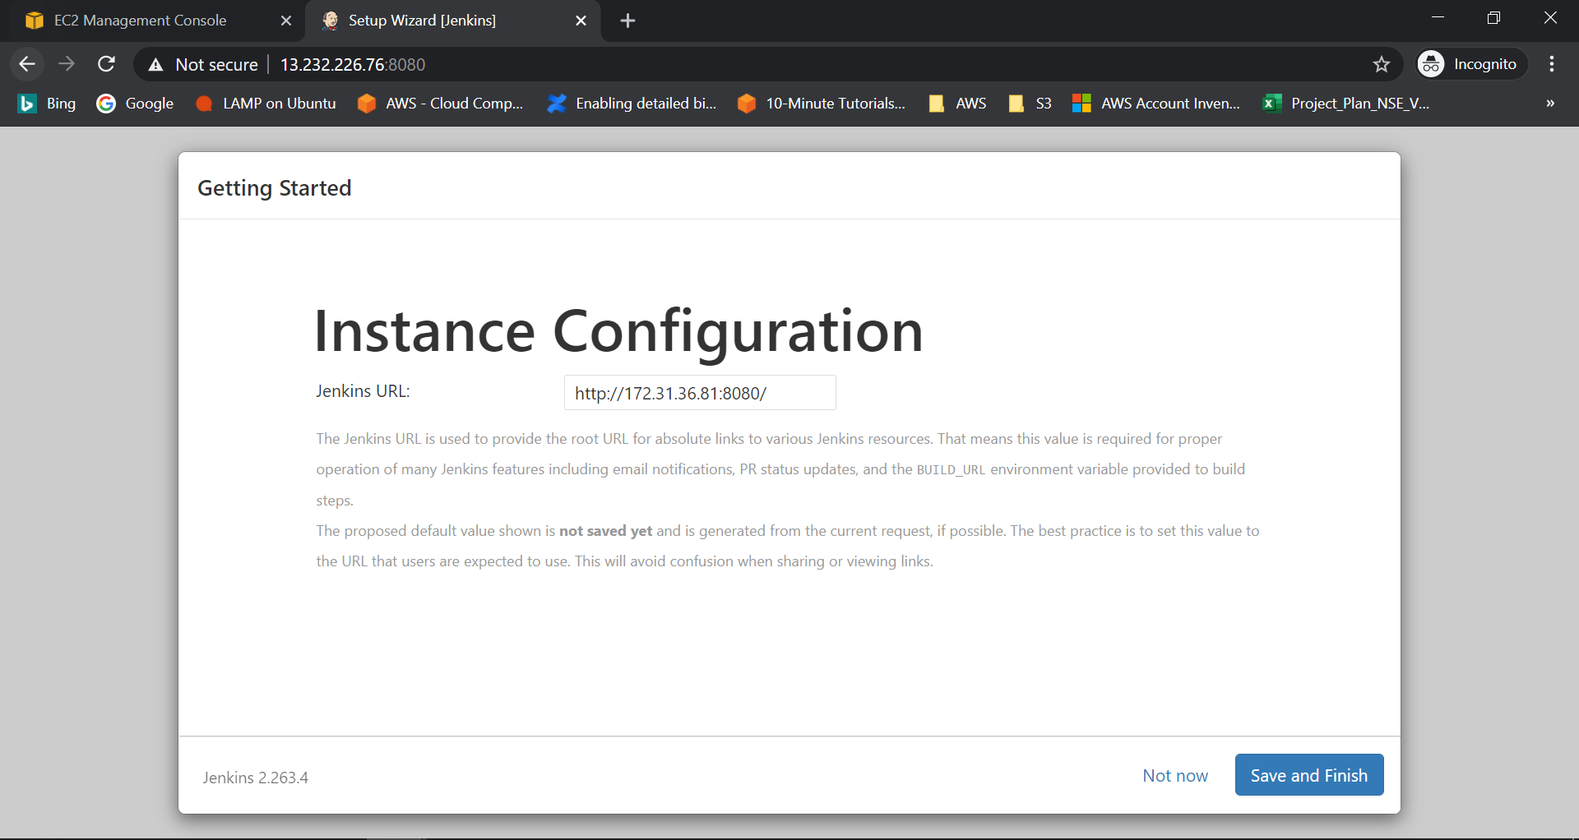

Step 02: Creating Multi-branch Pipelines

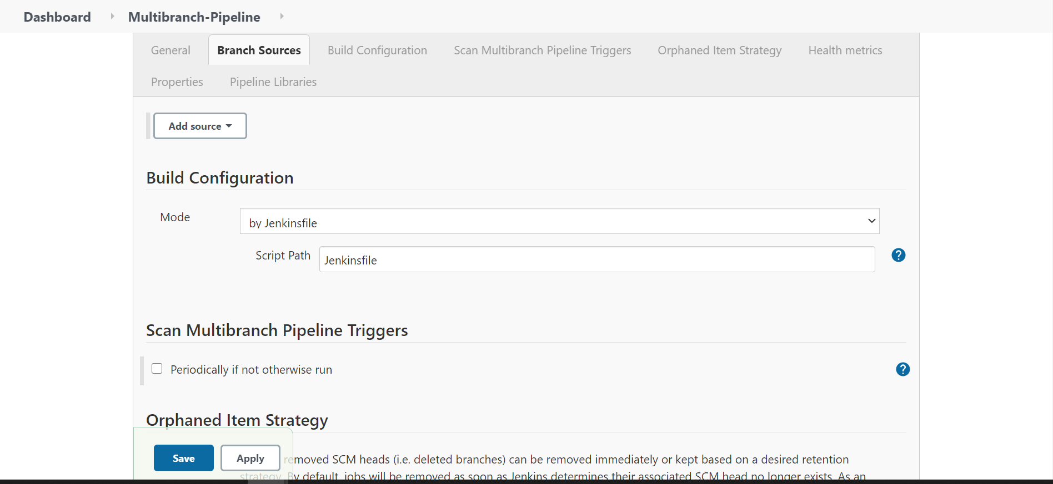

Jenkinsfile: is the text file which contains the definition of Jenkins Pipeline and is checked into source code.

